

MAIN/HOME PAGE

… …

…

… …

…

K’dabr 9 Members

Next: (NAME), (PLACE), (TIME)

… …

…

… …

…

… …

…

Groups: .

My Profile

Event Planner

Add a star mark if they own it/ favorite





Black Box is an icon of the simple description

Create Event

(NAME) (TYPE)

(DATE) (TIME) (#) Attending

(LONGER________________________________________________________________________DESCRIPTION)

(#) Comments

(NAME) (TYPE)

(DATE) (TIME) (#) Attending

(LONGER________________________________________________________________________DESCRIPTION)

(#) Comments

FEED

9 Members

(GROUP)

Event Planner

GROUP PAGE

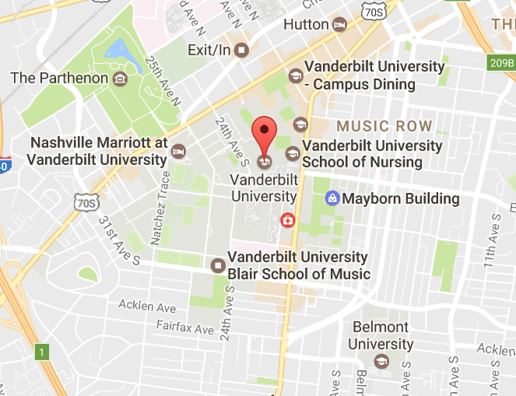

Description

Location

Type

Time

Date

Event Name

Event Planner

EVENT CREATION PAGE



(VENUE NAME)

(TAGS)

(VENUE NAME)

(TAGS)

(VENUE NAME)

(TAGS)

(VENUE NAME)

(TAGS)

Check chooses a place

Plus allows you to add to a variety of lists

(VENUE NAME)

(TAGS)

Type

(OPTIONS) Nearby

Event Planner

SIMPLE DESCRIPTION PAGE

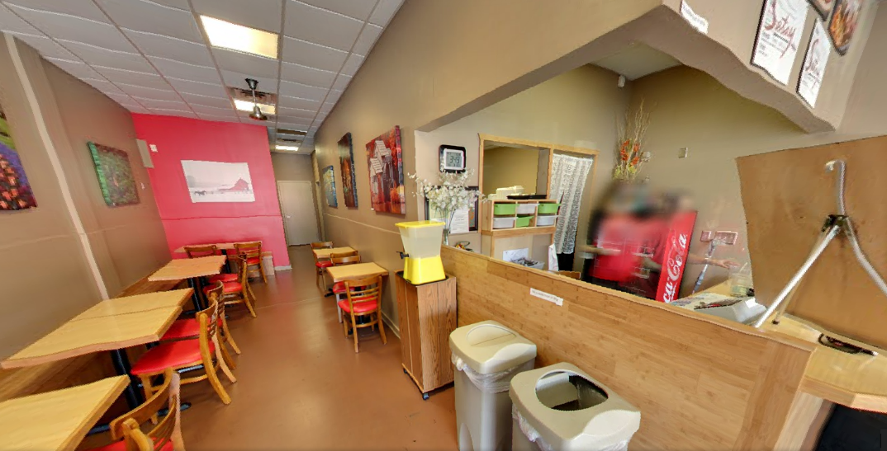

CHOOSE

NAME Preference

(NAME) (Preference)

(NAME) (Preference)

(NAME) (Preference)

(NAME) (Preference)

(NAME)

Phone #: (#)

Location: …

Tags: …

Event Planner

DESTINATION PAGE